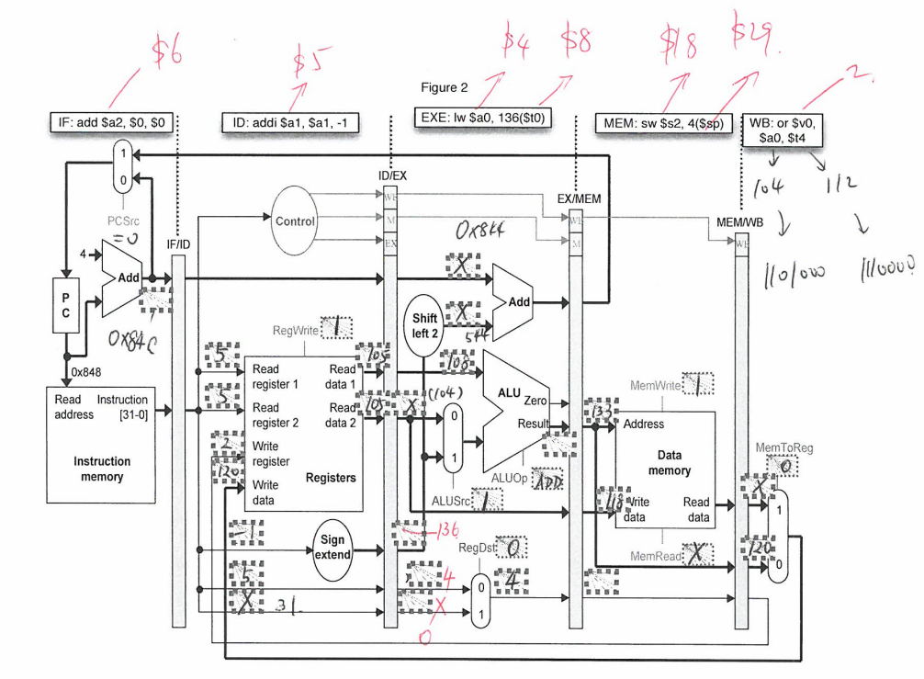 Consider a 2-way set-associative cache that uses 10-bit cache index and has 32-byte cache blocks. If a machine uses 32 bit physical addresses, compute:

|  |  |  |
| --- | --- | --- |
| Tag | Index | Offset (range) |
| 17 bits | 10 bits (Given) | 5 bits (#Of bits to make 32) |

• the number of blocks in the cache: 2*210= 2048

• the size of the block offset: 5 Bits

• the size of the tag: 17 Bits

|  |  |  |
| --- | --- | --- |
| Tag | Index | Offset (range) |
| Remaining bits | 1 bit (# bits to make 0d2 | 2 bits (#Of bits to make 0d4) |

Consider a 2-way set-associative cache with a total of 4 blocks of 4 bytes each:

|  |  |  |
| --- | --- | --- |
| Set | Block | Block |
| 0 |  |  |
| 1 |  |  |

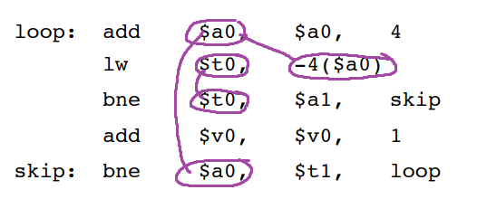

|  |  |
| --- | --- |
| Set | Block |
| 0 |  |
| 1 |  |

|  |  |  |
| --- | --- | --- |
| Tag | Index | Offset (range) |
| Remaining bits | 1 bit (# bits to make 0d2 | 1 bit (#Of bits to make 0d2) |

Given a direct-mapped cache with 2 blocks of 2 bytes each.

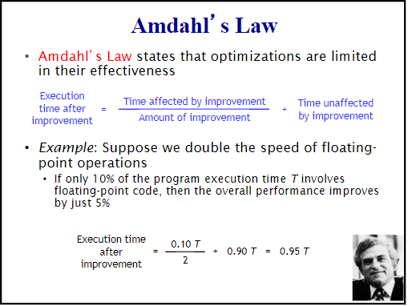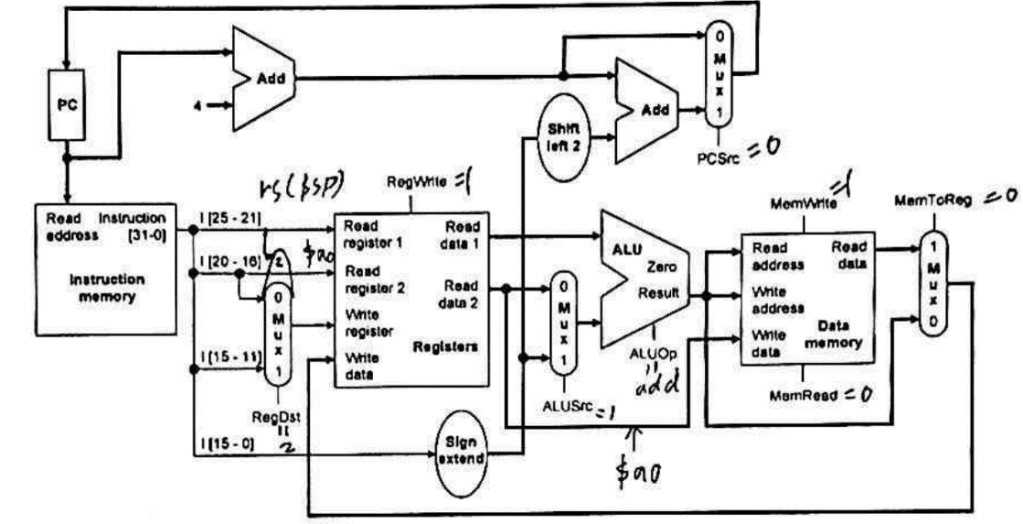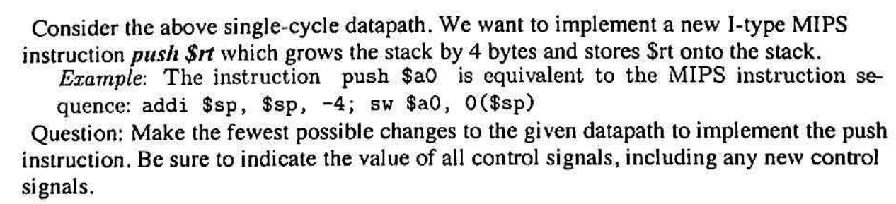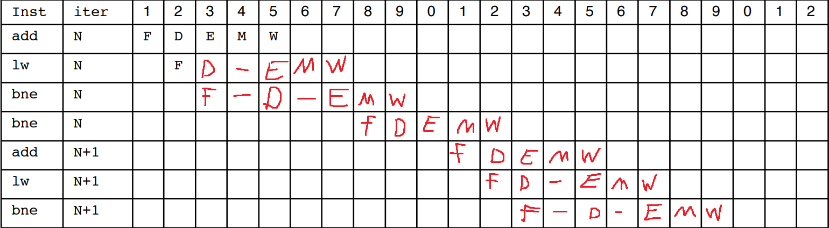 Direct mapping means 1Block/set